**Database Comparison Mysql**

**Features**

1. Compare 2 databases of the same connection.
2. Compare 2 tables and all tables.

**Technologies used for code development:** HTML, CSS, PHP, JavaScript, MySQL

**Technologies you need**

This project is specifically for comparing MySQL databases. To run this project, you will need a server that can run PHP code and a browser to view the pages.

**How to run the project**

1. Go to config.php add your connection details.
2. Next, go to the browser and type localhost/database_comparison_mysql/select_db.php

**Two Tables**

1. Select Databases and click “Select Tables”.

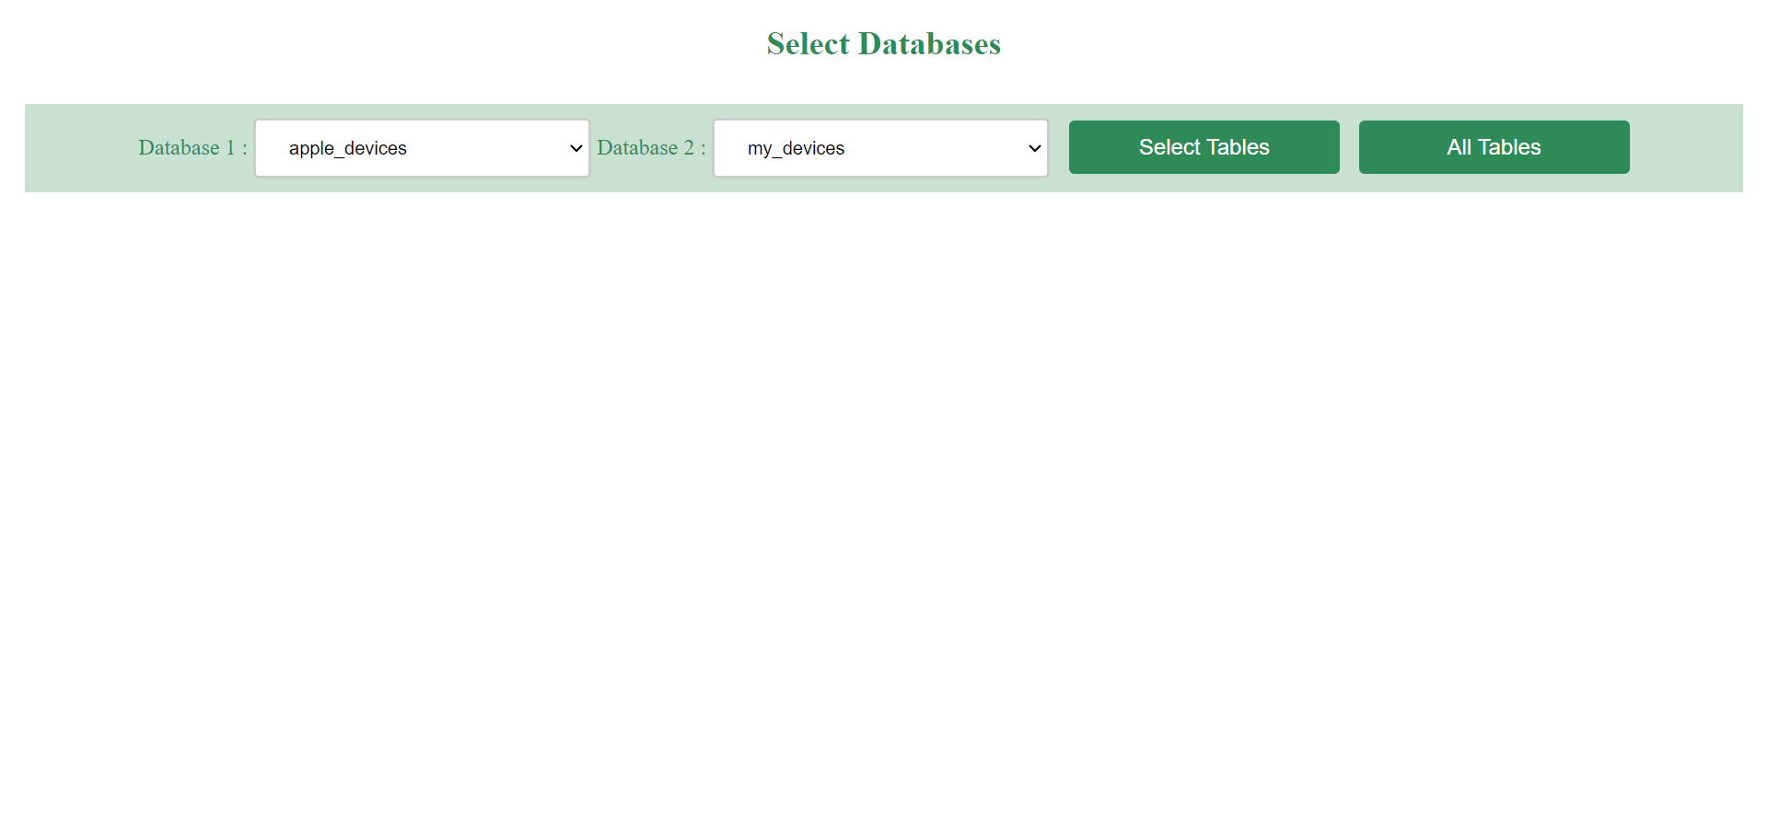

1. Select Tables and click “Submit”.

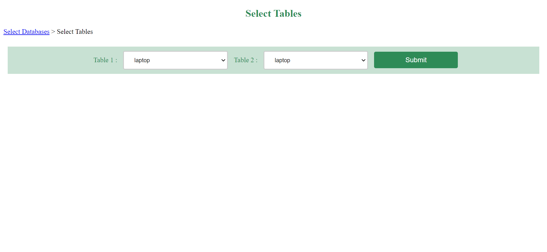

1. View matching and non-matching columns of two tables

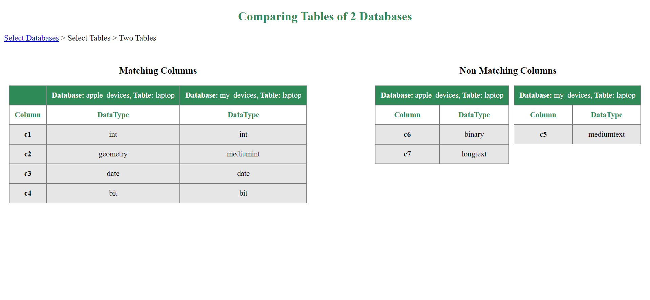

**All Tables**

1. Select Databases and click “All Tables”.



1. View Matching and Non-matching tables of all tables.

